

Executive Summary
BuyOut is a GCC-based fintech platform that empowers individuals to regain control of their finances by consolidating and converting conventional debt into Sharia-compliant, transparent, and manageable financing.
It unifies all forms of personal liabilities — credit cards, car finance, personal loans, and BNPL debt — into a single ethical loan through a seamless digital experience.

The Problem
In the UAE and GCC, consumer debt is high, fragmented, and interest driven.
Over 60% of salaried residents manage multiple liabilities across banks and lenders, while the refinancing process remains manual, opaque, and time-consuming.
Borrowers face:
- High and compounding interest rates (riba-based structures).
- Complex paperwork and branch visits for refinancing or consolidation.
- No digital marketplace to compare or switch to Sharia-compliant alternatives.
Household debt in the UAE exceeds USD 450 billion, equal to 106% of GDP (CEIC Data, 2023). Yet, most of this market lacks automated and ethical refinancing options.

The Solution
BuyOut bridges technology, finance, and ethics.
Through open-banking APIs and AI, it:
- Aggregates all active loans and liabilities.
- Analyzes repayment schedules and eligibility.
- Provides multiple Sharia-compliant refinancing offers from partner banks.
- Executes buyouts digitally and automates contract generation (Murābaḥa, Tawarruq, Ijāra).
- Enables in-app payment management, deferrals, and live credit tracking.
The result is lower monthly payments, ethical alignment, and total transparency — achieved in minutes, not weeks.

Market Opportunity
- UAE household debt: USD 457.5B (CEIC, 2023).
- GCC refinanceable exposure: ~USD 50B among salaried borrowers.
- Muslim-majority market: 70%+ of the GCC population seeks ethical financing options.
- Open-banking regulations (UAE, KSA) create a clear path for fintech-led refinancing.
Even a 1% penetration of this market (~USD 500M in refinancing volume) positions BuyOut for rapid profitability and unicorn-scale valuation.

Competitive Edge
Market Gap | BuyOut Advantage
Manual refinancing process | Fully digital automation via Open Banking APIs
Limited Sharia-compliant products | Converts any loan into certified halal finance
Single-bank loan options | Multi-lender marketplace with transparent comparisons
Long approval times | Under 30-minute digital processing
Fragmented payment management | Unified wallet with scheduling and deferrals
BuyOut uniquely combines ethical compliance, digital automation, and cross-lender connectivity, giving it first-mover advantage in the region.

Business Model & Financials
- Revenue Streams:
  - Loan transaction fees (1–2%)
  - Lender commissions (per conversion)
  - Micro deferral fees (AED 5–60)
  - Credit analytics subscriptions & data insights
- Gross Margin: ~70%
- Breakeven: Year 2
- Projected Revenue: AED 20.5M by Year 3
Pre-Seed Raise: AED 5M (~USD 1.36M)
Runway: 18–20 months
Series A Target: USD 40–50M valuation by Year 3

Team & Governance
Led by an experienced fintech and Islamic finance team:
- CEO: 10+ years in GCC digital banking and Islamic fintech.
- CTO: Expert in open-banking systems and AI automation.
- Chief Compliance & Sharia Officer: Certified by AAOIFI.
Supported by a Sharia Advisory Board, Fintech Regulatory Advisors, and partnerships under the DIFC/ADGM fintech frameworks.

Vision
To become the ethical financial backbone of the GCC, giving every individual the power to manage and refinance their debt transparently, affordably, and in line with their values.

BuyOut
BuyOut is a digital platform that allow users to view all their institutional debts and be able to refinance them based on their debt prioritization and need. We allow users to conduct buyout activities through a fully digitalized process that rely on multiple technologies to make a previously lengthy and manual process a quicker and simple one.
BuyOut is simply an aggregator for Sharia compliant lenders to be able to provide their refinancing/buyout services through a digital platform that bridges the gap between them and those who are seeking their services in the UAE.
At BuyOut we leverage the power of technology and Islamic Finance to enable customers to manage their debts in accordance with their monthly financial capabilities and refinance their debts through trusted partners, simple steps, automation, soft credit history check and quick processing periods.

Quick Sharia-Compliant Buyout
Different Debts

Mission
To position BuyOut as a main channel for debt refinancing.
Vision
We vision to become a one-stop shop for multiple Sharia-compliant financial tools that allow individuals to access lending, Micro-lending, investing, access credit and manage wealth while ensuring better financial benefits and keeping their values aligned with their financial goals.
Values (TTAS)
Trust
Transparency
Simplicity
Automation

Problem & Solution
Problem: Individuals across the United Arab Emirates (GCC as well, but out of scope at this stage) seek refinancing services for their different loan types to be able to repay those loans or to restructure them in a way suitable with their monthly financial capabilities. Currently, accessing these services is done through conventional channels of the providers which has the following limitations:
- Manual
- Lengthy
- Doesn’t offer the best rates
- Hard credit score check
- Requires the bank to reach out to clients or personal efforts
- Hidden costs
- Mostly conventional loans
- No ability for repayment management or a unified debt viewing
Despite high digital adoption and a clear preference for quick refinancing services refinancing and debt buyouts remain slow, opaque, and inaccessible by many consumers as the process or the service itself isn’t at a seamless stage.
This has led consumers to struggle with accessing quick to acquire refinancing solutions, conduct buyouts via an automated processing, maintaining healthy Credit Score, managing multiple loans and managing re-payment plans.
- High Debt Exposure
Over 60% of UAE residents hold at least one active loan or credit facility (personal, car, or credit card). Many manage 3–5 separate debts simultaneously. Link.
- Interest-Dominated Market
Around 80–85% of consumer lending in the GCC is still interest-based, leaving Muslim borrowers with few halal alternatives. Link.
- Fragmented Obligations:
Multiple due dates, lenders, and repayment apps lead to confusion and missed payments that damage credit scores and increase costs. Research results.
- Manual and Opaque Buyouts:
Loan buyouts require physical paperwork (salary certificates, cheques, liability letters) and take 7–10 working days with unclear early-settlement penalties. Survey results.
- Lack of True Comparison:
“Loan comparison” platforms only collect leads; they don’t execute buyouts or show live repayment data, leaving users guessing about the real cost. Link.
- No Digital Solution:
There is currently no unified digital platform in the UAE/GCC that consolidates debt, converts it to Sharia-compliant finance, and automates repayments end-to-end. Research results.

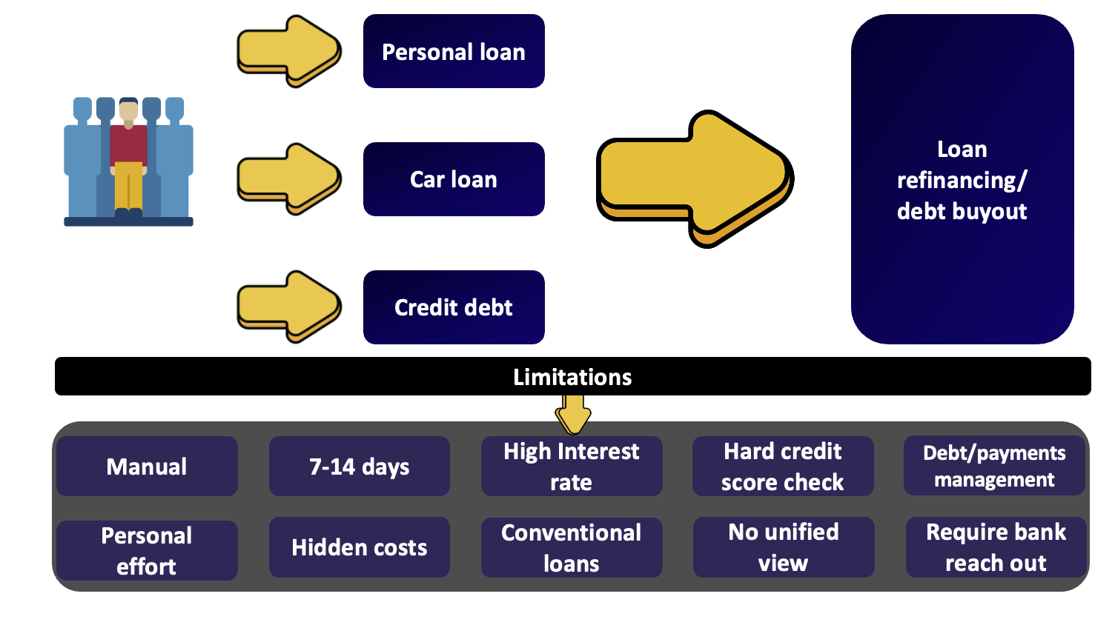

Solution: BuyOut is a digital platform and Sharia-compliant loans aggregator that simplifies, automates, and ethically transforms how people in the UAE manage and refinance their loans. It empowers users to refinance all their liabilities, convert them into Sharia-compliant buyouts, and regain financial comfort and clarity — all through a single digital process.
- Fragmentation → Unification
Users currently manage multiple loans scattered across banks.
BuyOut unifies all these obligations into one clear structure — one payment, one plan, one ethical path.
- Interest Exposure → Ethical Conversion
Most users are trapped in interest-based loans due to limited access to halal options and lengthy processes. BuyOut enables them to refinance existing loans into certified Sharia-compliant structures, removing the ethical and spiritual burden of Interest and accessing better profit rates and lower monthly payments.
- Manual Process → Full Automation
Refinancing today requires paperwork, visits, and long delays.
BuyOut automates this process end-to-end using open banking APIs, digital contracts, and instant lender settlement.
- Opaque Costs → Transparent Value
Borrowers rarely understand the real cost difference between offers.
BuyOut displays true profit rates, repayment timelines, and total payable amounts with full clarity, giving users control and trust.
- Financial Stress → Manageable Freedom
By merging payments and offering optional flexibility, BuyOut helps users manage cash flow, avoid penalties, and improve their credit health — transforming anxiety into stability.
Digital debt management

BuyOut benefits
Debt paid

BuyOut platform
Debts

Seeking a buyout

Products and Services
Products description: BuyOut is a digital Islamic debt-refinancing platform that enables consumers in the UAE to aggregate all existing debts, convert them into Sharia-compliant loan, and manage repayments seamlessly — all in one app.
BuyOut acts as a neutral intermediary marketplace between users and lending institutions or banks, powered by open-banking APIs and Sharia-certified contracts (Murābaḥa, Tawarruq, Ijāra).
BuyOut is a bridge between riba-based credit and ethical digital finance through automation, transparency, and compliance.

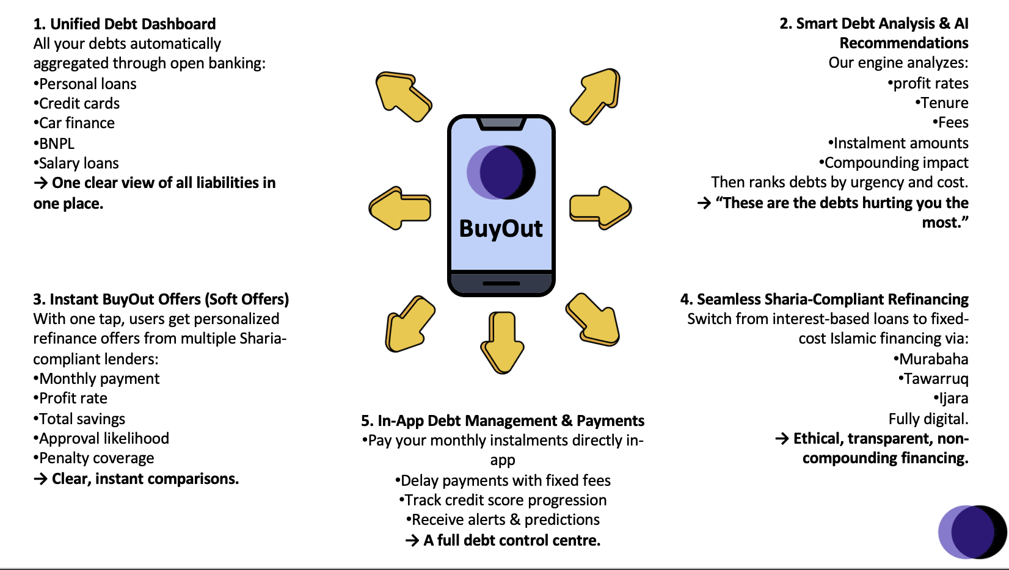

How It Works (Conceptual Flow excluding basic steps)
- Debt Aggregation → User connects bank accounts via open-banking consent; BuyOut imports active liabilities and payments.
- Analysis & Conversion Proposal → AI-based engine list loans based on amounts and due dates for user to conduct a total buyout for all liabilities or they choose certain liabilities. The engine then prepares compliant financing structures.
- Marketplace Offers → Partner Islamic banks and lenders present competitive profit-rate offers; users compare based on cost, monthly payment, tenure, or benefits.
- Digital Contracting → Once accepted, e-contracts are generated and digitally signed; BuyOut settles the existing debts on behalf of the user.
- Unified Repayment → All new payments occur through BuyOut’s, users track schedules, credit-score, and available flex options and pay directly through our payment facilitation with lenders.
Core Features
Category | Description
Unified Debt Dashboard | Consolidates personal, car and credit-card obligations into one view
Sharia-Compliant Refinance Engine | Converts riba loans into halal finance via certified contracts.
Offer Marketplace | Displays multiple lenders offers with transparent profit-rate and total payable.
Digital Settlement & e-Contracts | Executes buyouts instantly through verified lenders using digital signatures.
In-App Payments | Allows direct repayment, tracking, and small deferral fees (AED 5–60).
Credit Score Insights | Pulls AECB data to show live score and improvement tips.
Smart Notifications & AI Insights | Predicts cash-flow pressure and alerts users before due dates.

Tech Stack & Role of APIs
Layer | Technology / Partner | Function
Frontend | React Native / Flutter | Cross-platform mobile app (Android + iOS)
Backend | Node.js / NestJS + Python (FastAPI) | Core logic, AI engine, integration orchestration
Database | PostgreSQL + MongoDB | Structured + dynamic financial data
Open Banking APIs | Platforms like Tarabut Gateway, Dapi, Lean Technologies | Aggregate liabilities, initiate payments, validate income
AECB Integration | UAE Credit Bureau API | Fetch credit reports, update scores
Smart Contracts Engine | Internal Sharia-compliance module | Generates Murābaḥa / Ijāra / Tawarruq contracts
Payment Gateway / Wallet | Network International / Stripe MENA | Secure repayments, fee processing
Analytics Layer | Power BI / Tableau Embedded | Dashboards for users and lenders
Cloud Infra | AWS MENA Region | Secure hosting under UAE data-sovereignty regulations
APIs are the foundation: they let BuyOut connect live loan data, perform instant settlements, and automate contracts — turning what takes 10 days on paper into a 10-minute digital flow.
Benefits to Customers (Users)
Pain → Relief | Impact
Multiple debts across banks | One consolidated plan with a single affordable monthly payment
Interest-based loans (riba) | Conversion into halal, Sharia-certified financing
Confusing offers & paperwork | Transparent comparison and digital execution
Long settlement delays | Instant buyout via open-banking payment initiation
Monthly stress | Smart notifications, optional payment flexibility, credit-score visibility, low monthly payments
Lack of trust | Clear disclosure of profit rate & total cost; certified ethical compliance

Benefits to Lenders (Partners)
Value to Lenders | Explanation
Qualified Lead Flow | Access to pre-screened, credit-verified borrowers via API integration.
Lower Acquisition Cost | Automated onboarding reduces branch & sales expenses.
Portfolio Diversification | Enables banks to expand Islamic financing to new demographics.
Regulatory Compliance | Fully Sharia-certified contracts, compliant with UAE CB & SAMA rules.
Data Insights | Access to anonymized borrower analytics for better risk pricing.
Brand Visibility | Ethical finance positioning through BuyOut’s marketplace presence.

Strategic Positioning
BuyOut sits between borrowers seeking refinancing services and lenders, a digital, trusted intermediary, not a bank or a conventional lender.
It monetizes through:
- Lender referral fees – Lenders (1% phase 1)
- Buyout processing fees – Borrowers (Phase 2)
- Deferment fees – Sharia compliant fixed fees, Borrowers (Phase 2)
- API monetization – Lenders (Phase 2)
BuyOut becomes the renewed refinancing-infrastructure layer for UAE then GCC consumers, transforming how debt is managed, refinanced, and made compliant.
Lenders
Islamic financial solutions
Islamic credit markets



UAE/GCC consumers
New verticals
Muslim consumers
Market Analysis
The UAE household debt size is both broad and on continuous growth, creating a high-value entry point for BuyOut. Household debt in the UAE stood at approximately USD 149.1 billion (around AED 1.68 trillion) as of latest reports in Sep 2025, and that level of debt is equivalent to 25% of the country’s nominal GDP. In addition, the country’s Non-Performing Loans ratio stood at 4.1% in Dec 2024 compared to 4.7% in the previous quarter. This indicates not only high borrowing levels, but also deep reliance on personal credit products to finance day-to-day living, cars, housing, and consumption.
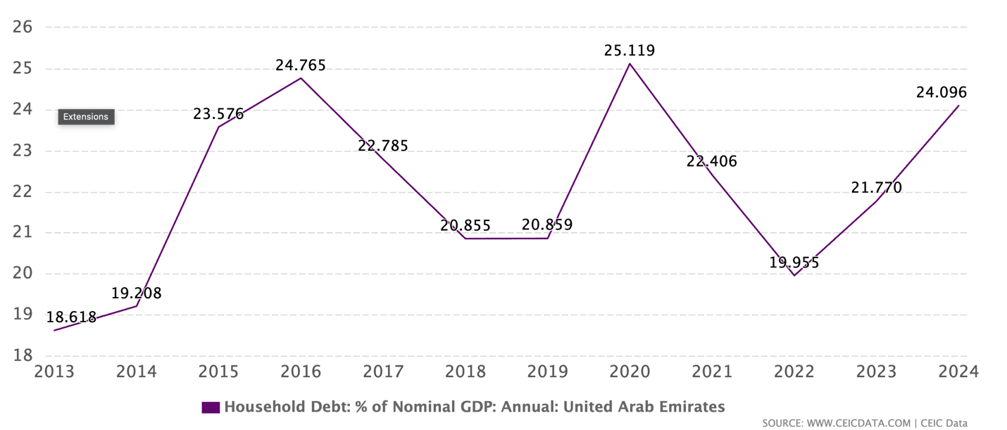

Meanwhile, most of this borrowing is still structured and serviced through traditional bank processes. Consumers who try to refinance or consolidate their liabilities — for example, combining a personal loan, car finance, and credit card balance — are generally required to produce physical salary certificates, liability letters from current lenders, bank statements, and post-dated cheques, and then wait 7–10 working days for approval and settlement. This is true even when the product is marketed as “liability settlement,” “buyout,” or “one payment” by UAE banks. The process is slow, manual, and favours the bank, not the borrower.
At the same time, most available refinancing is either (a) conventional interest-based debt or (b) a single Islamic bank’s internal buyout product. There is no neutral, digital marketplace that allows a borrower to (i) view all current debts in one place, (ii) convert interest-bearing facilities into Sharia-compliant financing, and (iii) execute the buyout and repayment plan through a single platform. Existing comparison sites in the UAE, such as YallaCompare and MyMoneySouq, list personal loan rates (including “Islamic finance” tags and flat vs. reducing rates) but do not actually settle the old debt, generate a new contract, or provide ongoing repayment management.

This leaves three structural pain points in the UAE retail debt refinancing market:
- High leverage at the household level with significant exposure to personal and consumer loans.
- Operational friction and opacity in refinancing and buyouts, even for Islamic products.
- No digital, lender-agnostic way to exit riba-based loans into certified Sharia-compliant finance and manage repayment in one place.
Current providers model
Finance House / CapitalZone / UAECashLoans brokers
- Manual paperwork, agent driven.
- Focus on lowering monthly payment through longer tenor.
- No Sharia framing.
- Bottom-right (Digital + Conventional)
YallaCompare / MyMoneySouq
- Digital comparison of personal loans and rates.
- Shows “best offers” but doesn’t refinance, buy out, or settle debt.
- Still interest-based loans in many cases.
- Top-left (Manual + Sharia)
Islamic banks (Dubai Islamic Bank consolidation finance, Emirates Islamic, ADIB buyout, Al Hilal settlement of liabilities)
- They can offer Sharia-compliant contracts (murabaha, tawarruq).
- They can buy out your old debt.
- But: it’s branch-led, slow, single-bank, and not transparent on total cost.
- Top-right (Digital + Sharia)
BuyOut
- Fully digital journey (aggregation → refinance → settlement → repayment).
- Converts interest-bearing loans into Sharia-compliant financing.
- Marketplace across multiple Islamic lenders, not just one bank.
- Single-payment plan with in-app repayment and payment flexibility.
- Credit score visibility and improvement loop.
- That “digital + halal + consolidation + execution” corner is BuyOut’s wedge.

Market Size
UAE household debt alone was about USD 149.1B (≈ AED 547.5 billion) as of Dec 2025. KSA, with a larger population and a very active personal finance / car finance market, adds a huge base. GCC-wide household/consumer liabilities go into the hundreds of billions of dollars.
We can conservatively frame TAM as ~$149B+ in household/consumer liabilities across the UAE, including personal loans, auto finance and credit cards.
SAM (People we can serve in Phase 1)
Who fits BuyOut’s profile?
- Salaried residents in UAE holding 1+ active debts (e.g. personal loan + card, car loan, Credit cards). These are the people who feel real payment stress and are most motivated to refinance or “Seeking halal buyouts”
- UAE working/salaried population ~7M+.
- If ~15% are multi-obligation borrowers, that’s 1.05M people.
If average outstanding refinanceable debt per qualified user is, say, USD $20k–$30k (personal loan + car + card rollovers), the SAM in pure refi volume is on the order of:
1.05M users × ~$30k each ≈ $31.5B refinanceable exposure in UAE.
Our SAM ~$31.5B+ in realistic, refinanceable, stressed debt among already-indebted salaried users in the first two core markets.
SOM (What BuyOut can take)
Let’s say in early years BuyOut can win:
- 1% of that refinanceable pool in UAE.
- 1% of ~$31.5B ≈ $315M+ in refinanced/converted volume flowing through the platform.
We’ve already seen what that means for expected revenue:
A 1% platform markup on $315M+ over multi-year tenors is roughly $3.15M+ gross revenue equivalent, without counting for other revenue streams or other features upsell.
At $1.26B+ in volume (4% capture), you’re in $12.6M+ per year territory.
Buyout can be a multi-hundred-million-dollar credit rail with embedded monetization.

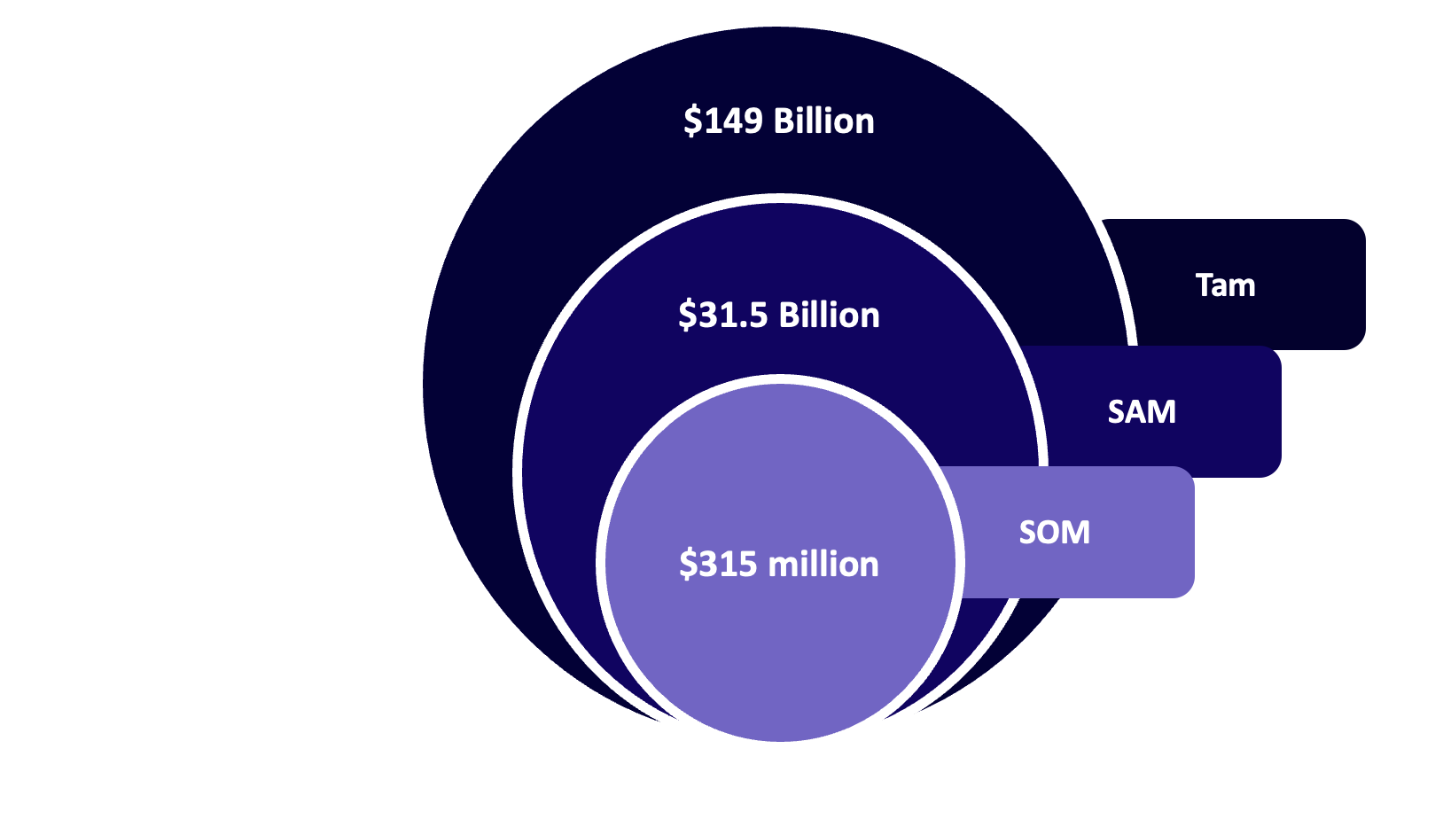

Gap Analysis: Why BuyOut Wins
Dimension | Pain in Market Today | How Competitors Handle It | BuyOut Advantage
Debt buyout/consolidation | Users juggle personal loans, auto loans, cards, BNPL separately | Banks or lenders: only consolidate into their own product; brokers: manual | consolidates liabilities with buyout offers from multiple providers
Sharia compliance | Majority of loans are still interest-based despite demand for halal alternatives | Islamic banks offer halal loans, but slow/on-branch; no marketplace | instant refinance into certified Sharia contracts, from multiple Islamic partners
Transparency | Users can’t tell total payable or effective cost; flat vs reducing is confusing | Comparison sites show marketing rates, not true cost over time | shows profit rate, reducing-equivalent, total payable, and repayment timeline clearly
Process speed | Refinancing requires salary letters, liability letters, cheques; takes 7–10 working days | Manual, phone calls, branch visits | API-led KYC, digital contract, automated settlement
Offer control | Users don’t control the “why” of the refinance (lower EMI vs halal vs lower total) | Banks optimize for their margin, not user objectives | BuyOut lets user choose priority (cash flow, total cost, halal) and ranks offers accordingly
Post-refinance management | User still pays different lenders and tracks manually | No one solves post-loan life | BuyOut becomes the payment hub: one wallet, one schedule, optional deferral for micro-fee, credit score feedback
Geographic ambition | Most players are UAE-bank centric | YallaCompare is UAE-focused comparison, banks are country-bound | BuyOut is region-wide (UAE first, then KSA, Kuwait, Oman) with cross-border Islamic liquidity sources

Takeaways
- Banks can’t/won’t do it because they only sell themselves.
- Aggregators don’t do it because they don’t execute.
- Brokers can’t scale it because they’re offline and conventional.
- BuyOut is a new category: a digital, Sharia-compliant, lender-agnostic debt infrastructure layer.
BuyOut vs Competitors
Feature / Capability | BuyOut | YallaCompare | MyMoneySouq | Banks and other lenders | Finovative / CapitalZone / Brokers
Core Model | Digital Islamic refinancing & consolidation platform | Loan comparison website | Loan comparison aggregator | Single-bank debt buyout product | Manual loan brokerage
Debt Aggregation | ✅ Multi-lender via open-banking APIs | ❌ No | ❌ No | ❌ Single bank only | ❌ Manual user data
Islamic Conversion | ✅ Converts riba loans to halal finance | ❌ No | ❌ No | ✅ Only if Islamic bank | ❌ Conventional only
Loan Consolidation | ✅ Yes, across multiple banks & loan types | ❌ No | ❌ No | ✅ Single-bank consolidation | ✅ Manual consolidation
Digital Settlement | ✅ Full e-contracts & API-based payment | ❌ No | ❌ No | ❌ Requires branch visit | ❌ Manual
Lender Marketplace | ✅ Competing Sharia lenders | ✅ Yes (limited to display) | ✅ Yes | ❌ Single lender | ❌ Manual
Transparency & Ratings | ✅ AI-driven “best offer” scoring | ⚠️ Basic comparison | ⚠️ Basic comparison | ❌ Opaque fees | ❌ None
User Wallet & Payment Control | ✅ Yes (in-app wallet) | ❌ No | ❌ No | ❌ Bank-based repayment | ❌ No
Credit Score Integration (AECB) | ✅ Live tracking & improvement suggestions | ❌ No | ❌ No | ✅ Static credit check | ❌ No
Payment Flexibility | ✅ Delay options (AED 5 – 60 fee) | ❌ No | ❌ No | ❌ Fixed payment terms | ❌ No
Target Market | Multi-debt salaried individuals (UAE, GCC) | General UAE consumers | General UAE consumers | Existing bank customers | Walk-in refinancing seekers
Positioning | Ethical digital aggregator & refinancing infrastructure | Price comparison | Rate listing | Bank loan replacement | Manual consultancy
User Experience | 100 % digital + Sharia compliant | Informational only | Informational only | Traditional | Manual

Product Model
Operating Model
BuyOut functions as a licensed digital intermediary, not a direct lender. It sits between borrowers, lenders, and regulators, managing & automating the refinancing and Sharia-conversion process.
Flow Overview:
- User Onboarding – eKYC, bank-account linking, credit-score retrieval via Open-Banking and AECB APIs.
- Liability Aggregation – platform pulls current personal loans, credit cards debts, and car-finance exposures.
- Eligibility & Conversion Analysis – AI engine evaluates payoff amounts, tenure left, income, and credit risk to propose suitable Sharia contracts (Murābaḥa / Tawarruq / Ijāra).
- Marketplace & Offer Selection – partner Islamic lenders publish profit-rate offers (This is listed on backend based on lenders selection criteria and debts classification; users view transparent comparisons of suitable offers and select one.
- Execution – BuyOut triggers debt settlement from lender A to lender B, issues new digital contract, and activates repayment through BuyOut wallet.
- Servicing & Monitoring – recurring payments, optional deferral, real-time credit-score tracking, and lender dashboards handled by the platform.
Regulatory Positioning & Compliance
- License Type: BuyOut operates under a “Fintech intermediary / loan marketplace” license, requiring registration with the UAE Central Bank (or a partner DIFC sandbox).
- Sharia Governance: All financing contracts are pre-approved by a certified Sharia Board.
- Data Governance: Complies with UAE Personal Data Protection Law No. 45 of 2021 and Central Bank Open Banking Framework.
- Settlement Control: Funds flow directly between lenders; BuyOut never holds principal, ensuring regulatory clarity and risk segregation.
Revenue Streams*Profitability is driven by transaction volume, low operating cost, and repeat users.
Channel | Mechanism | Typical Range / Value
Loan markup | 1% markup or success fee on refinanced loan amount | AED 10 – 20 M potential annually at scale
Lender commission | Flat rate per successful buyout | AED 200 – 500 per case
Deferment Fees | AED 5–60 per payment-deferral request | Recurring micro-revenue
API Monetization | open banking-style APIs for lenders, fintechs, and partners. | Monthly / annual plans

Risk & Compliance Model
Risk Type | Mitigation Method
Credit Risk | BuyOut never lends; exposure sits with banks.
Sharia Risk | Independent Sharia advisory committee validates each contract type.
Data Security Risk | AES-256 encryption, SSO auth, hosted on AWS MENA Region.
Operational Risk | API redundancy, automated monitoring, audit logs.
Regulatory Risk | Licensed under DIFC / ADGM sandbox phase; aligns with Central Bank Open Finance framework.

Scalability & Expansion Plan
- Phase 1: UAE launch (focus on salaried residents with multi-debt exposure).
- Phase 2: KSA expansion (integration with Saudi Open Banking Sandbox).
- Phase 3: Kuwait + Oman roll-out via same API architecture.
- Phase 4: Regional liquidity pool (cross-border Sharia-compliant refinancing with partner Islamic banks).
The modular API and Sharia contract engine allow expansion without re-engineering the core.

Business Differentiation Summary
Dimension | BuyOut Advantage | Impact
Position | Ethical fintech marketplace | First-mover in GCC
Product Depth | Consolidation + Conversion + Payment Hub | Full-lifecycle control
Partnership Model | Works with banks, not against them | Easier licensing, faster scaling
Revenue Diversity | Transaction, subscription, and data streams | Stable growth base
Tech Stack | Open Banking APIs + Sharia engine | Fast, compliant automation

Marketing and Sales Plan
BuyOut is a new service that solve crucial problem for the targeted segments, yet it is an unknown brand and solution that require robust waves of awareness campaigns and solution description. BuyOut marketing should be consistent and continuous until a direct link between the action of buyout and our startup is initiated by potential customers.
- I want to enhance my current loan/s profit rate
- I want to find a buyout provider to give me better loan rates or better monthly payments
- I’m seeking a Sharia compliant buyout
- I want to consolidate my loans
Hence our aim should be to place BuyOut as a synonym to the buyout action and consolidation which require us to build trust first.
Objective:
- Build trust & awareness
- Position BuyOut as the main way to conduct a buyout
- Acquire users
- Convert debt holders into BuyOut customers while forming long-term lender partnerships.
Marketing Strategy
A. Brand Positioning
- Position BuyOut as the trusted, ethical and digital alternative to conventional debt refinancing in the UAE.
- Core message one: “Freedom from interest, No hidden costs.”
- Core message two: “Easy consolidation &quick Sharia compliant buyouts.”
- Core message three: “Lower monthly payments & lower loan profit rate.”
- Core message four: “Refinance your debt with three clicks and from home.”
B. Target Audiences
Segment | Description | Primary Channels
Salaried Residents (24–55) | Expats & locals with multiple liabilities | Social media, digital ads, salary-partner employers, lender channels
Islamic-Conscious Borrowers | Muslims seeking halal financing | Islamic communities, influencers, podcasts
Banks & Lenders | Islamic & conventional banks seeking ethical conversion partners | B2B partnerships, fintech summits, direct sales
Customer Acquisition Plan

A. Digital Marketing
Channels: Instagram, Facebook, YouTube, Google Ads and TikTok with A/B tested creatives.
- Performance & before/after campaigns
- “Save AED 3,000 per month” angle.
- Enter your current loan terms (Rate and tenure) and compare possible better rates on BuyOut
- Lower your monthly payments today by x%
- Educational content
- Sharia-compliant refinancing (video explainers, infographics).
- Implications of Interest based loans for Muslims
- Values of loans consolidation
- SEO & Blog
- Halal finance” and “debt consolidation UAE” long-tail content targeting.
- Buyout UAE
- Low-rate loans UAE

B. Partnerships
- Partner with Islamic financial products providers and Islamic loans lenders
- Collaborate with Islamic influencers and community organizations to promote ethical finance awareness.

C. Public Relations
- Announce launch in major UAE fintech, business media & Islamic finance bloggers (The National, Arabian Business, Zawya).
- Showcase success stories: before-and-after user savings and ethical switchovers.

Conversion Strategy
Funnel Stage | Tactic | KPI
Interest → Sign-Up | click open-banking integration and onboarding | Conversion rate > 10%
Sign-Up → Offer View | Personalized loan analysis dashboard | Engagement rate > 50%
Offer → Acceptance | Gamified comparison (“Top 3 Sharia Offers for You”) | Conversion rate > 30%
Acceptance → Funded | Instant e-contracts and settlement automation | Drop-off < 15%

Retention & Growth Strategy
Mechanism | Description | Value
BuyOut Wallet | Manage and pay all loans in one place | Monthly engagement loop
Credit-Score Insights | Personalized alerts and “Halal Credit Health” tracking | Continuous monitoring
Deferral Micro-Fees | AED 5–60 charge for payment reschedules | Stickiness + revenue
Referral Program | AED 100 cashback or fee waiver for each referral | Viral growth engine
Offer alerts | Continuous offers that might have offer  Term | Stickiness

Sales Tactics (B2B and B2B2C)

A. Lender Partnerships
- Loan markup: Lenders pay a 1% markup for each new loan originated via BuyOut.

B. Employer Channels
- Partner with HR & payroll providers (Bayzat, Hafilat, Emirates HR) to offer BuyOut as an employee benefit for financial wellness.

C. Institutional Alliances
- Sign with Islamic banks, fintech sandboxes, and Sharia certification boards to build credibility and secure compliant partnerships.

KPIs & Milestones
Phase | KPI | Target
Q1–Q2 Launch | User sign-ups | 10,000(65K per debtor)
Year 1 | Loan consolidations processed | AED 650M
Q3–Q4 Scale | CAC < AED 100 | Retention > 60%
Year 2 | Total loans managed | AED 1.95B
 | Active lender partners | 10+ Islamic & conventional

Key Advantages in Market Entry
- First-mover advantage in digital + Sharia-compliant + automated buyout & loan refinancing
- High consumer trust via ethical positioning
- Recurring user engagement (wallet, credit tracking, deferrals)
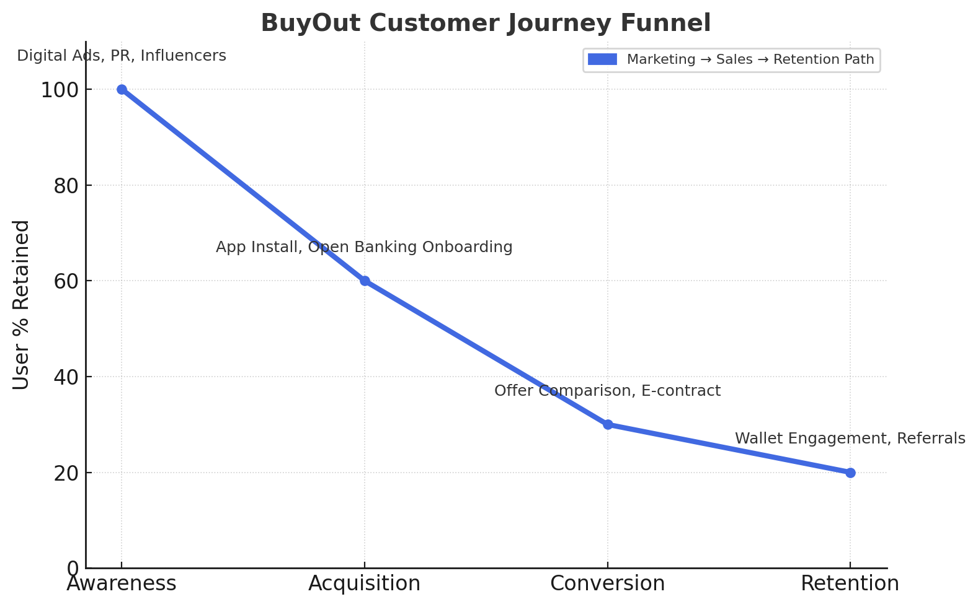
- Scalability across GCC with low incremental acquisition cost

Operational Plan
Platform Architecture & Core Infrastructure
BuyOut operates as a cloud-native fintech platform built around four core layers:
- Frontend Layer (UX/UI):
  - Web + Mobile apps (React Native / Flutter).
  - Unified design system ensuring regulatory transparency (loan breakdown, Sharia contract clarity).
- Backend Layer (Microservices):
  - Modular architecture on AWS (Lambda + API Gateway).
  - Services for: loan aggregation, contract generation, lender-matching, payment scheduling, and wallet ledger.
- Data & Integration Layer:
  - Open Banking APIs: connects securely to UAE banks (via Central Bank’s open finance framework).
  - AECB Credit Bureau API: fetches credit history and score in real time.
  - Sharia Engine: dynamic contract generator for Murābaḥa, Tawarruq, and Ijāra transactions.
  - Payments Gateway: integration with UAEPASS, Stripe MENA, and network settlement rails for monthly payments.
- AI & Analytics Layer:
  - AI-driven recommendation engine (selects optimal refinance or conversion offer).
  - Risk modelling and affordability scoring.
  - Dashboard analytics for lenders (user segment insights, performance reports).

Daily Operations Workflow
Function | Responsibility | Tech/Process
User Onboarding | Digital KYC, account linking | UAE PASS API, OCR document validation
Loan Aggregation | Retrieve all active debts | Open Banking + AECB API integration
Analysis | Debts analysis | AI model
Offer Generation | Match user to lender & Sharia structure | AI scoring + partner bank APIs
Buyout Execution P1 | Offer selection, form input | Database
Payment Servicing | Process monthly payments & deferrals | Wallet + recurring billing microservice
Customer Support | In-app chat + email | Zendesk API + automated chatbots
Compliance & Audit | Track Sharia adherence & transactions | Blockchain-based contract registry (phase 2)

Operational Location & Resources
- Headquarters: DIFC Innovation Hub (regulatory sandbox entry).
- Engineering Hub: Remote-first, GCC-based developers under hybrid model.
- Compliance Office: Abu Dhabi (liaison with Central Bank + Islamic authorities).
- Customer Support Center: Outsourced BPO in Sharjah for 24/7 multilingual assistance.

Regulatory & Legal Operations
- Licensed under the Central Bank of UAE Fintech Sandbox initially.
- Transition to ADGM / DIFC Fintech License for regional scaling.
- Sharia Advisory Board certifies all contracts quarterly.
- Legal Partners: Partner law firm oversees data protection, KYC/AML, and open finance compliance.

Technology & Security Operations
- Cloud Infrastructure: AWS Middle East (Bahrain region).
- Database: PostgreSQL (encrypted at rest).
- Monitoring: Datadog + AWS CloudWatch.
- Data Protection: AES-256 encryption, tokenized user data.
- Disaster Recovery: 99.9% uptime SLA; active backups every 12 hours.
- Audit Logs: Immutable records for regulatory and Sharia oversight

Lender & Partner Management
- Dedicated Partnership Team manages onboarding of Islamic and conventional lenders.
- API Integration Protocols: Each lender receives SDK for direct integration.
- Revenue Reconciliation: Automated daily settlement reports between BuyOut and partner banks.

KPIs for Operations

Metric | Target (Year 1) | Target (Year 2)
Avg. loan approval time | < 30 minutes | < 15 minutes
System uptime | 99.9 % | 99.95 %
Customer satisfaction (CSAT) | 85 % | 92 %
Average cost per transaction | < AED 5 | < AED 3
Partner lenders integrated | 5 | 15

Scalability & Automation
- Phase 1 automation: onboarding + buyout execution.
- Phase 2 automation: cross-lender settlements + Sharia compliance blockchain record.
- Phase 3 automation: AI-based portfolio optimization and regional cross-border loan portability.
Management and Organization

Founding Team
Name / Role | Background & Expertise | Key Responsibility
Founder & CEO | Founder | Vision, fundraising, partnerships, product-market strategy.
CTO / Co-founder | Co-founder | Tech infrastructure, product roadmap, security & compliance systems.
Chief Compliance & Sharia Officer | Former advisor to Islamic banks; certified by AAOIFI; expertise in Murābaḥa, Tawarruq, and fintech Sharia frameworks. | Sharia governance, legal structure, and contract validation.
Chief Operations Officer | Experienced in scaling UAE-based fintechs; strong background in automation, customer lifecycle operations, and regulatory communication. | Day-to-day execution, KPI monitoring, operational scaling.
Chief Marketing Officer | Data-driven growth strategist with GCC digital marketing experience; led user acquisition for financial apps and BNPL startups. | Brand strategy, growth marketing, user retention.

Organizational Structure
BuyOut is structured for agility, compliance, and scalability:
Board of Directors
│
┌─────────────┼─────────────┐
│ │ │
Sharia Board Executive Team Advisory Board
│ │
Compliance Officer

┌──────────────────────┼────────────────────────┐
│ │ │
Product & Tech Operations Growth & Marketing
│ │ │
Dev / QA / API Teams Customer Support Performance, PR, Partnerships
& Risk Ops

Sharia Advisory Board
BuyOut will establish an independent Sharia Advisory Board (SAB) comprised of:
- Two Islamic finance scholars certified by AAOIFI.
- One Islamic banking practitioner with experience in UAE and KSA markets.
- One legal advisor specializing in Islamic financial contracts.
Roles:
- Certify all product structures (Murābaḥa, Tawarruq, Ijāra).
- Conduct quarterly audits on compliance and profit-rate transparency.
- Endorse communication for Sharia-marketing alignment.

Advisory Board
BuyOut’s advisory board includes industry experts from:
- Fintech Regulation: Former Central Bank sandbox participant.
- Open Banking Infrastructure: Advisor from a leading API fintech.
- Investment / Venture Capital: Early stage fintech investor with GCC network.
- Islamic Finance Academia: Professor or researcher in Sharia-compliant finance innovation.
These advisors guide on fundraising, licensing, partnerships, and global scaling.

Governance & Reporting
- Weekly leadership syncs on operations, user metrics, and compliance.
- Monthly Sharia audit summary ensuring every transaction remains riba-free.
- Quarterly board reviews of growth, lender relationships, and financial performance.
- Annual external audit aligned with UAE’s Fintech Sandbox and Central Bank guidelines.

Hiring Roadmap
Stage | Roles Added | Purpose
Pre-seed (Months 1–6) | Backend devs, Sharia compliance analyst, UX lead | MVP build, compliance onboarding
Seed (Months 6–12) | Product manager, marketing lead, lender relations exec | Scale partnerships & user acquisition
Series A (Year 2) | Regional ops heads (KSA, Kuwait), data scientists | Expansion & analytics optimization

Financial Plan

Startup Expenses (First 12 Months)
Category | Description | Estimated Cost (AED)
Technology Development | Platform build, API integration, cloud infrastructure | 1,200,000
Licensing & Compliance | DIFC sandbox setup, Sharia board certification, legal | 400,000
Marketing & Launch | PR, digital ads, content, influencer partnerships | 600,000
Team Salaries | Founding team + 5 core hires | 1,800,000
Office & Operations | DIFC workspace, tools, support systems | 300,000
Contingency (10%) | Reserves for unforeseen costs | 430,000
Total (Year 1) | 4,730,000 AED (~USD 1.28M)

Funding Requirements
Total Raise: AED 5 million (USD 1.36 million) pre-seed.
- Use of Funds:
  - 40% → Technology & infrastructure
  - 25% → Marketing and growth
  - 20% → Talent and operations
  - 10% → Compliance & licensing
  - 5% → Reserve buffer
Runway: 18–20 months before next round.
Next Raise (Seed Round): USD12–15$ million for expansion (More users & GCC potential).

Revenue Projections

Based on the following assumptions:

Total debt targeted = $315M
Debts per borrower= $30k
Total users= 10,500

Revenue Stream | Year 1 | Year 2 | Year 3
Loan markup revenue | 3.15M | 5.0M | 12.0M
Lender Commissions | 1M | 2.0M | 4.0M
Payment-Flex Fees (40% of users) | 28.5k | 1.0M | 2.5M
Premium Subscription & Analytics (5) | 57.2k | 0.6M | 2.0M
Total Revenue (AED) | 4.23M | 8.6M | 20.5M
Projections are based on USD at a rate of 3.67 AED (Growth 103% then 138.3%)
Revenue in AED (3 years)
Yr 1: 15,524,100 AED
Yr 2: 31,562,000 AED
Yr 3: 75,235,000 AED
Gross Margin: ~48.7%
Operating Profit Target (Year 3): AED 5–6M

Profit & Loss (Simplified Projection)
Metric | Year 1 | Year 2 | Year 3
Total Revenue | 4.23M | 8.6M | 20.5M
Cost of Goods (Tech + Processing) | 0.53M | 2.2M | 4.5M
Operating Expenses | 4.2M | 4.0M | 6.0M
Net Profit (Loss) | –0.5M | +2.4M | +10.0M
Breakeven: End of Year 2 (after ~25,000 processed loans).

Cash Flow Forecast (Key Drivers)
- Inflows: Refinancing volume + subscription renewals + micro-fees.
- Outflows: Cloud hosting, compliance, payroll, lender settlements.
- Cushion: AED 500k maintained in reserve for liquidity and AECB bond requirements.

Financial Assumptions
Parameter | Assumption
Average Loan Refinanced | AED 35,000
Average Platform Fee | 2.5% per loan
Users by End of Year 1 | 15,000
Loan Conversion Rate | 20%
Average Monthly Deferral Requests | 40% of users
CAC | AED 57
LTV | AED 110k
Gross Margin | 70%

Investor ROI Outlook
- Entry Valuation (Pre-seed): USD 10–15M.
- Target Valuation (Series A): USD 100–500M (Year 3).
- Investor Return Potential: 10–33x within 3 years (based on 10–15% equity stake).

